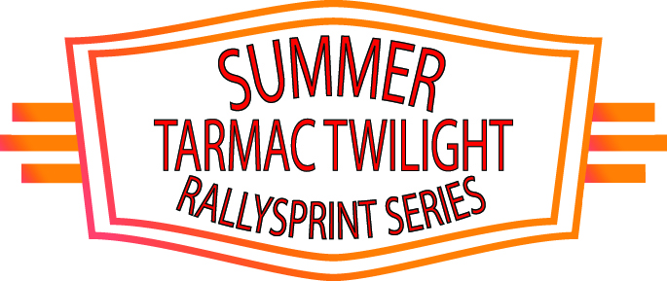
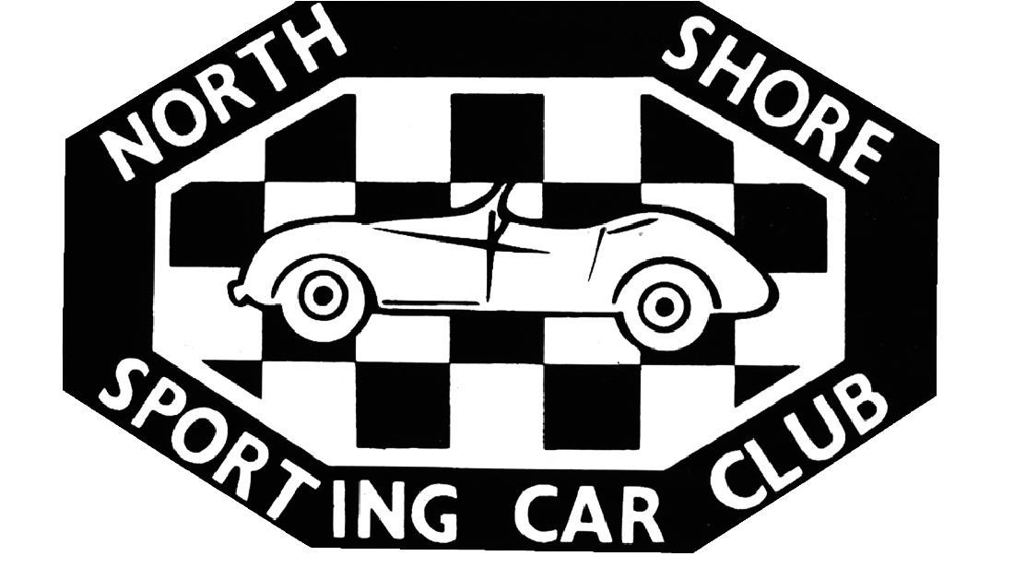

Entry Form
18 November, 2014

 | COMPETITOR  If Competitor is Driver leave blank | DRIVER | CO - DRIVER

Surname
Given Name
Date of Birth | / / | / / | / /
Address
 | Post Code | Post Code | Post Code
Car Club
Mobile  Phone | ( ) | ( ) | ( )
E-Mail
Address
Civil Drivers
Licence No.
CAMS
Licence No.

Description of Car
Make |  | Model | Year | Colour
Registration No. | Engine Capacity | Class A 2WD 0-2000 B. 2WD over 2001 E.2WD gravel tyres  C. 4WD 0-3500 D. 4WD over 3500 F. 4WD gravel tyres
Payment

PLEASE NOTE DO NOT POST. ELECTRONIC ENTRY IS FASTER AND MORE EFFICIENT
Event Rd 2 Twilight Tarmac Rallysprint ( Registered crew) $210.00

Event Rd 2 Twilight Tarmac Rallysprint ( Non Registered crew) $240.00

Cheque Visa Mastercard

Card Number ___ ___ ___ ___ / ___ ___ ___ ___ / ___ ___ ___ ___ / ___ ___ ___ ____ CCV ___ ___ ___ Expiry Date: ___ ___ / ___ ___

Card Holders Name (please print)
Card Holders Signature

If emailing please send to secretary@nsscc.com.au

Or pay on the NSSCC website secure payment portat at http://nsscc.com.au/instant-payment/

COMPETITOR, DRIVERS & CO-DRIVERS STATEMENT

For Competitors
I/We being the competitor/s of the vehicle described on this Entry Form wish to enter that vehicle for the above event.

For Competitors, Drivers and Co-drivers
I/We being the competitors/s and/or driver and/or co-driver, certify that the particulars on this form are true and correct in every particular, to the best of my/our knowledge and belief.
I/We declare that I/we have read and understood the Supplementary Regulations issued for the event, and agree to be bound by them and the provisions of the National Competition Rules of the Confederation of Australian Motor Sport Limited (CAMS).
In exchange for being able to attend or participate in the event (including entering the event), I agree:
- to release CAMS and Australian Motor Sport Commission Ltd, promoters, sponsor organisations, land owners and lessees, organisers of the event, their respective servants, officials, representatives and agents (collectively, the Associated Entities) from all liability for my death, personal injury (including burns), psychological trauma, loss or damage (including property damage) (harm) howsoever arising from my participation in or attendance at the event, except to the extent prohibited by law;
- that CAMS and the Associated Entities do not make any warranty, implied or express, that the event services will be provided with due care and skill or that any materials provided in connection with the services will be fit for the purpose for which they are supplied; and
- to attend or participate in the event at my own risk.
I/we acknowledge that the risks associated with attending or participating in the event includes the risk that I may suffer harm as a result of:
- motor vehicles (or parts of them) colliding with other motor vehicles, persons or property;
- acts of violence and other harmful acts (whether intentional or inadvertent) committed by persons attending or participating in the event; and
- the failure or unsuitability of facilities (including grand-stands, fences and guard rails) to ensure the safety of persons or property at the event.
- motor sport is dangerous and that accidents causing harm can and do happen and may happen to me.
The route instructions should not be relied upon exclusively in estimating the degree of severity of any hazard which might be encountered, or the manner in which any section of the road is driven, whether shown in the route instructions or not, and that I/We have been advised to exercise caution in following these route instructions.
I/we acknowledge that my/our personal information will be processed in accordance with the CAMS privacy policy which is available from www.cams.com.au and where I/we suffer from any injury, sickness or death during the Event, I/we consent to the release by health services of my/our personal health information to any authorized representative of CAMS or the Event who may use it in the preparation and release within and outside Australia of accident or incident information and reports to interested parties for the purpose od accident investigation, accident prevention and safety activities, news services including broadcast services, or for the purpose of processing insurance claims.
I accept the conditions of, and acknowledge the risks arising from, attending or participating in the event and being provided with the event services by CAMS and the Associated Entities.
I understand that this disclaimer is not intended to exclude any valid claim I may have under the CAMS Personal Insurance Scheme.
Competitors's signature: ......................................…….....……....................…............ Date: ..................................…....
Driver/s signature: ...............................................………....................…........... Date: ................................…......
Co-Driver/s signature: ............................................……..................…............. Date: .........................................

PARENT’S / GUARDIAN’S PERMISSION

(To be completed by the Parent / Guardian for any crew member who is under 18 years of age)
I, …………………………………………………………… of[Address] ………………………………………………………………………
………………………………………………………………………………………… am the Parent / Guardian* of the above-named
………………………………………………………………………………. (“the minor”) who is under 18 years old. I have read this document and understand its contents, including the exclusion of liability and assumption of risk, and have explained the contents to the minor. I consent to the minor attending/participating in* the event at his/her own risk.
Signature ……………………………………………... Parent / Guardian* Date ………………………………
Address: ……………………………………………………………………………………………………………………..
* Delete whichever does not apply.

