2017/ 18

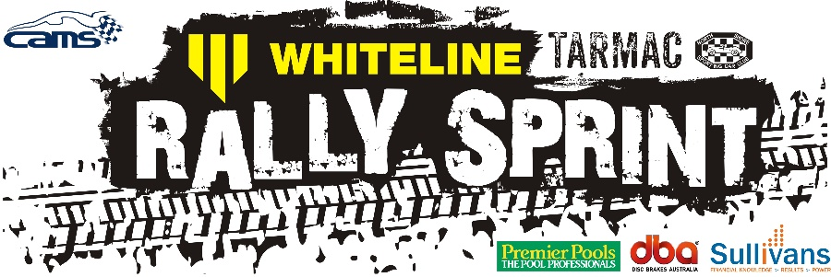
EVENT SERIES DATES
- Thursday October 19, 2017
- Tuesday November 14, 2017 note Tuesday
- Thursday December 7 2017
- Thursday February 15, 2018
- Thursday March 15, 2018

VENUE
Sydney International Dragway
Eastern Creek
MORE INFO
http://nsscc.com.au/twilight-rallysprint/
https://www.facebook.com/NorthShoreSportingCarClub/

